Lab Manual



SUPERIOR UNIVERSITY LAHORE PAKISTAN

LAB -05

Task 1

**Design network of "Lab-7" and “Lab-8” (2-3 rows of computers) &**

**“Admin” Use: • Server (for each, total 3)**

**• Switch (3)**

**• Router (1)**

**• End-Devices like Laptop/PC**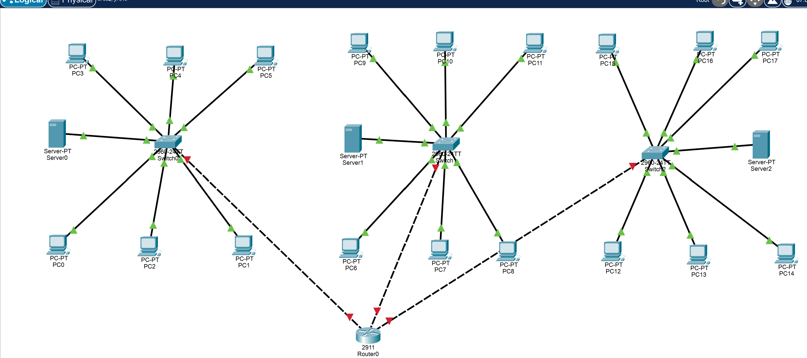

**Assign them IP Address (Dynamically/DHCP)**

**• Lab 7: 192.168.1.0**

**• Lab 8: 172.168.5.0**

**• Admin: 158.168.4.0**

